Tensorflow Image Classification

Class Demonstration Notes

Team Albert

TABLE OF CONTENTS

RUNNING TWO DEMO IN NOTEBOOK

Tutorial Set Up

Part A: Google Colab Notebooks

Part B: Jupyter Notebooks

Tutorial Set Up

We will use JupyterNotebooks as our coding environment.

Go to this Github repo to download the whole Tutorial:

<https://github.com/BenchengW/Facial-Recognition-MMAI844-Tutorial>

Click the green button to download the code and unzip it on your local directory

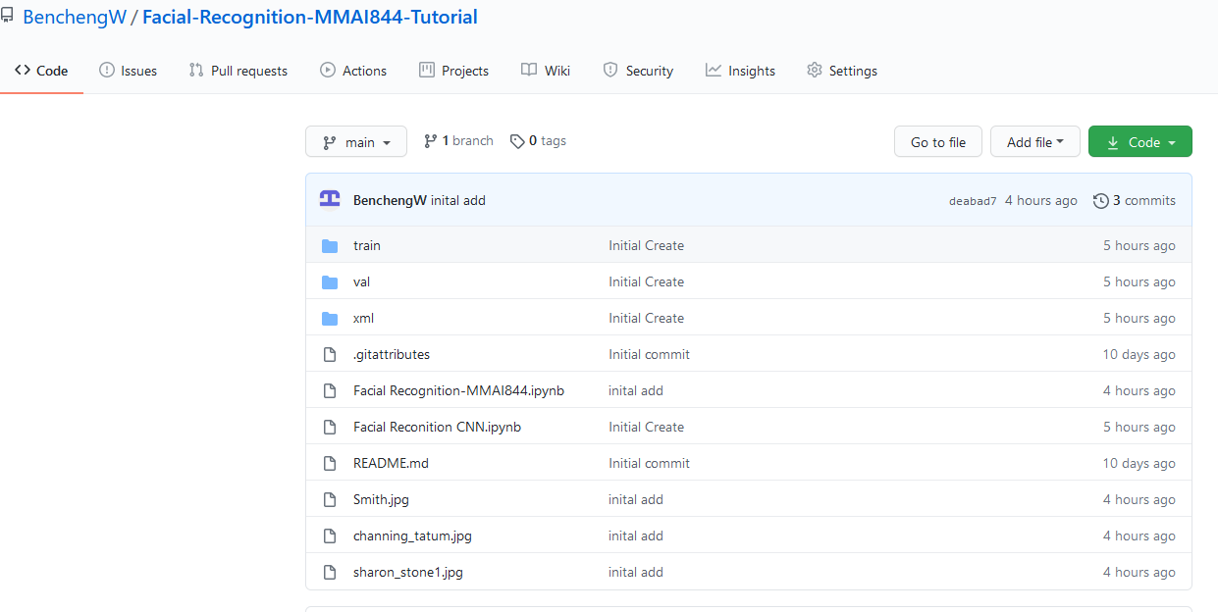

Part A: Google Colab Notebooks

We will use **JupyterNotebooks** as our coding environment. If you have a notebook environment you like to use, please use it. If not, I suggest using **Google Colab**

**(see link below)**.

Step 1:

Go to <https://colab.research.google.com/notebooks/intro.ipynb#recent=true>

to open Google Colab. Upload the **Recognition-MMAI844- Colab Version.ipynb** by clicking upload button.

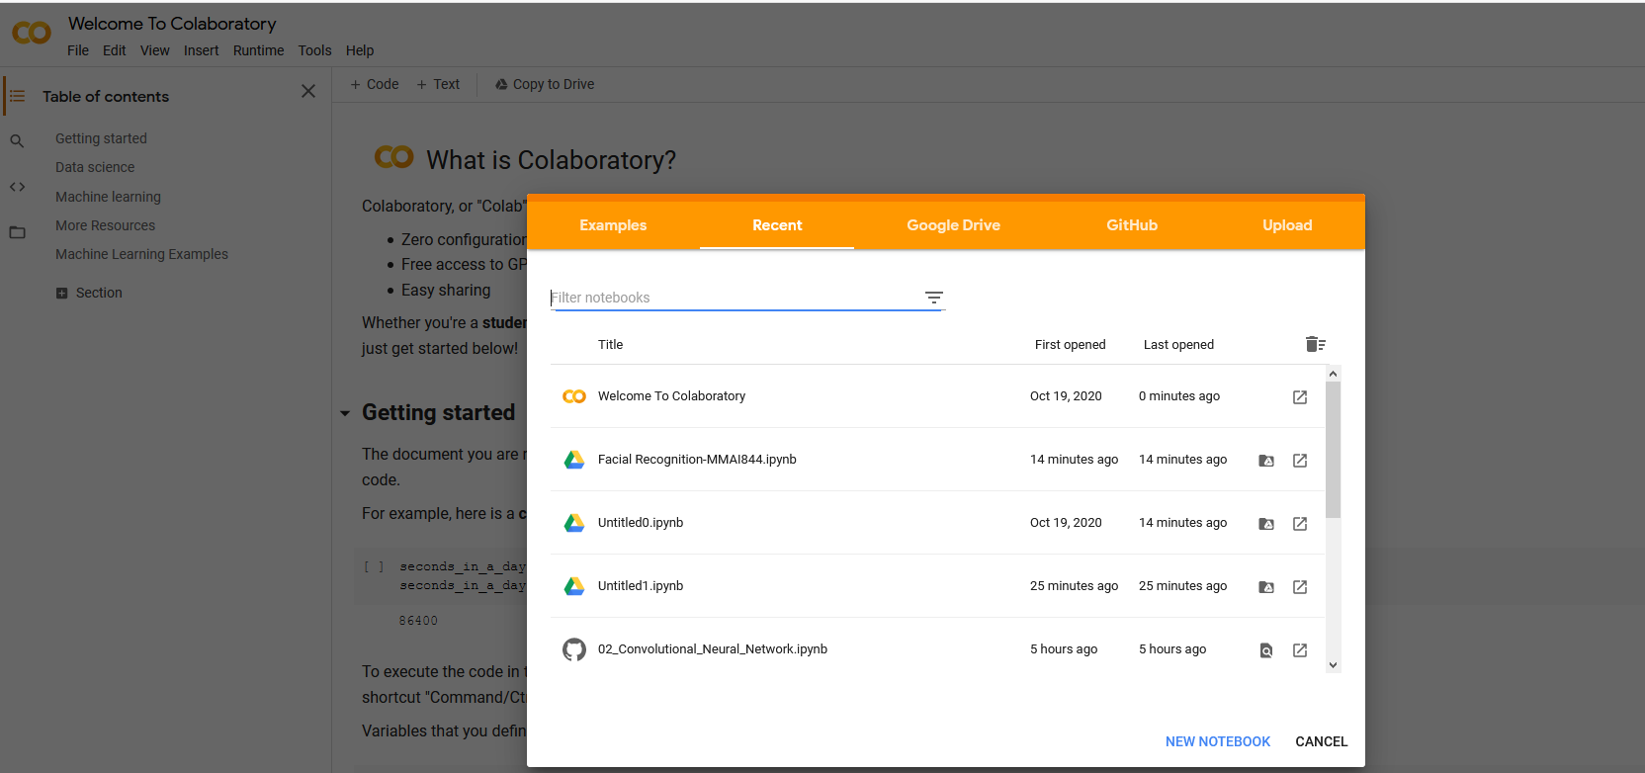

Step 2: Git clone the data from Github Repo

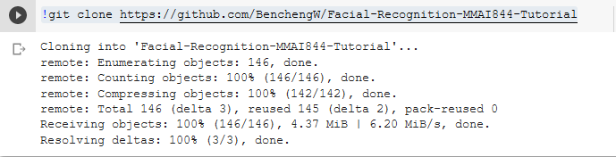

Step3: Install Necessary Libraries

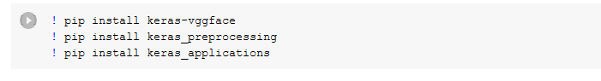

Step 4: Running each step in **Recognition-MMAI844- Colab Version.ipynb**

Step 5: For **Recognition-MMAI844- Colab Version.ipynb** take a screen shot for final prediction accuracy

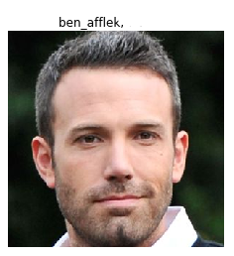

Step 6: Open **Object Recognition CNN-MMAI844.ipynb** and run each step. Take a screen shot for final TensorBoard

Part B: Jupyter Notebooks

Open your Jupyter Notebook and run **Recognition-MMAI844.ipynb file.**

Please open the notebook Facial Recognition-MMAI844.ipynb for your Tutorial. Please follow below step to install necessary packages before the tutorial.

Step 1: Open Juptyer Notebook

Open any Jupyter Notebook and open the Recognition-MMAI844.ipynb

Step 2: Install Necessary Libraries

Run the commend on first and second line in the notebook:

! pip install -r requirements.txt

!pip install git+https://github.com/rcmalli/keras-vggface.git

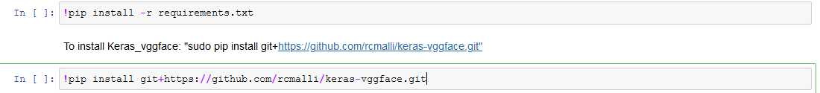

Step 3: Running each step in **Recognition-MMAI844.ipynb**

Step 4: For **Recognition-MMAI844.ipynb** take a screen shot for final prediction accuracy



Step 5: Open **Object Recognition CNN-MMAI844.ipynb** and run each step. Take a screen shot for final TensorBoard